Chapter 12, Solution 38.

As a balanced three-phase system, we can use the per-phase equivalent shown below.

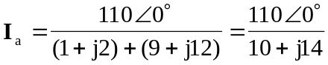

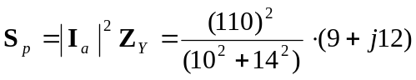

The complex power is
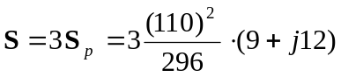

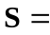 (1.1037+j1.4716) kVA

